***VEDIC VILLAGE REVIEW #51***

**October 25, 2017.** **Adventures in New Jaipur, Prabhupadanuga Farm in Fiji**

**THE LOST JADE**

Six years ago we planted four jade vine plants on the farm. They take a few years to flower, and when they do, it is always as though some celestial aircraft had accidentally dropped a heavenly plant on their way through the airways. We had found some seeds with a Mrs. Mukherjee in Lami on the other island in 2009, an old lady who lived in a small cottage completely overgrown with trees, flowers, vines and ferns, surrounded by fences and huge raintrees. She also had given us a few fire jade seeds (flame red), but none of those survived. When we started to develop the New Jaipur farm in 2011, I planted two blue jade vines, one under a raintree and the other under a huge gnarly Ivi tree, both along our river. But a worker chopped both vines unknowingly while they thought they were cleaning weeds and brush. The third green jade vine thrived in an old mandarine tree next to the milking shed, but it collapsed in a storm and the vine, perhaps a hundred feet long and an inch thick, came tumbling down and died. The fourth one was forgotten and we thought we were jade-less.

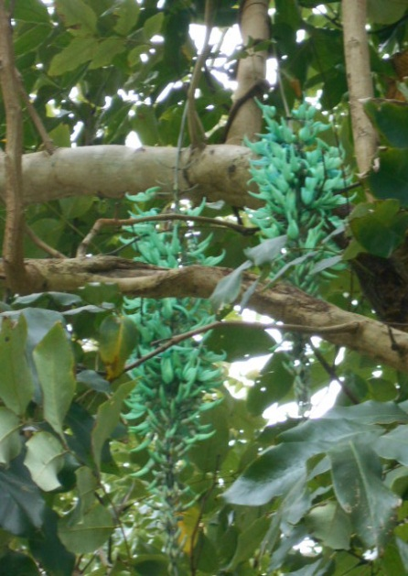 Then a few weeks ago, as I rushed to the kava dryer rack, and right beside the ashrama lodge, I was shocked as I stepped upon dozens of blue-green jade flowers lying in the short grass. What? Looking up into the very tall yellow shower tree cluster above me, I finally located the lost jade… a brilliant, seductive blue-green jade explosion hanging from the end of an unseen vine, shedding flowers one at a time over many days of ocean sea breezes. A small miracle, and a pleasant one. So the lost jade has revealed itself. There were two panicles of jade, as the vine must have split into two somewhere above. I collected jade flowers for tomorrow’s guru-puja, and noticed that they came in two colors, one more blue, the other more green, but both like the seagreen shallows of the ocean bay out in front of me.

It’s a good feeling to have something special to offer to Sri Sri Radha Govinda and Srila Prabhupada for the morning worship. Next I checked if there were any new strawberries in the berry bed nearby.

**THE DARKEST HOUR**

*''Civilization will collapse very soon, all over the world......our farm project are an extremely important part of our movement. We must become self- sufficient by growing our own grains and producing our own milk, then there will be no question of poverty. So develop these farm communities as far as possible. If these farms become successful then the whole world will be enveloped by Krishna consciousness. Krishna is the Farm Acharya, Baladev is holding a plough, and Krishna is holding the calf. The Krishna consciousness movement will go down in history as having saved mankind in its* ***darkest hour.****" (Quote from Srila Prabhupada)*

**WIDE EXPECTATIONS FOR THIRD WORLD WAR**

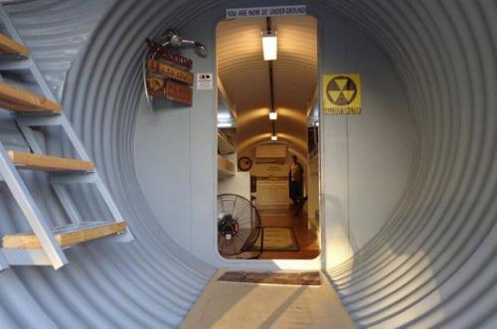 Everywhere in the news these days we see widespread preparations and expectations, anxiety and discussions about WW3. The level of insanity and aggressive confrontations as well as suspicious events like the Las Vegas mass shooting and North Korean rhetoric is unprecedented. Sales in the USA of properties and homes in “safe” locations and war/bomb shelters of all types have increased dramatically as people sense something wicked is coming soon. It is in the air, yet, of course, most everyone just continues their lives hoping for the best. Many news stories speak of the destruction of mankind and all life on the planet if there is a nuclear war. However, Srila Prabhupada said this was not possible, but that modern civilization will be severely disrupted, especially the cities. The large cities of the world are very vulnerable to even moderate disruptions to the flow of goods and people which WW3 would certainly bring in a major way. It does not make sense, but the demoniac are intent on works to destroy as much as they can. The future of the planet is not bright in any political, social, or economic dimension.

Here is a photo of an underground war shelter for a family; the manufacturers cannot keep up with their orders.

The insanity is overwhelming these days: genetic modifications of live human fetuses, plans to live on Mars, uncontrolled pollution such as the Yamuna, sex changes on young children, race consciousness and hatred, and unbridled aggression by the USA worldwide. In the upcoming event of major international turmoil and war or wars, including very likely nuclear war, among the results for the general mass of population will be these problems:

**FOOD:** Within days, local food supplies can easily run out. Then what? Eat tires or plastic?

**WATER:** Most water that people use in the modern countries is supplied by the government. In the event of power disruptions, financial upheavels, etc… how can water supplies continue for sure?

**SAFETY:** The people will be squeezed between oppressive government forces, probably martial law, and renegades, desperados, criminals, gangs, thieves, etc.

Anyway, no one will take the inevitable chaos seriously until it arrives. But then it will be too late to avoid or make proper preparations; except for a few, such as those who took action in time by moving out of the cities and securing arable land, learning basic skills that have been today mostly lost.

Our Fiji island safe haven is a refuge for devotees who would agree to a few conditions for cooperative devotional life. Anyone interested in securing their future, please contact us.

**REPORT ON THE COWS**

Not able to import live milk cows from overseas or inter-island, we chose to take up artificial insemination, ordering frozen semen in a tank for “breeding up” the best cows we could find locally. In two years we managed to get one calf (Prema) and have decided that 3 or 4 of the 6 cows we started with must be barren. Nothing is easy in Kali yuga (except sinful activities!) In July we bred four cows again, and by Christmas we can check to see if anyone is expecting. We are expecting someone to be!

We include some photos of the cows in New Jaipur, as just to look at cows is auspicious, what to speak of protecting, feeding, touching, or naming them. They are Shyamali, Tungi, Lakshmi, Chandrika, Rukmini, and, of course, now Prema. We had a beautiful cow named Padma, with lotus eyes, but she passed away due to a poisonous weed that will affect some animals but not others (Lantana).

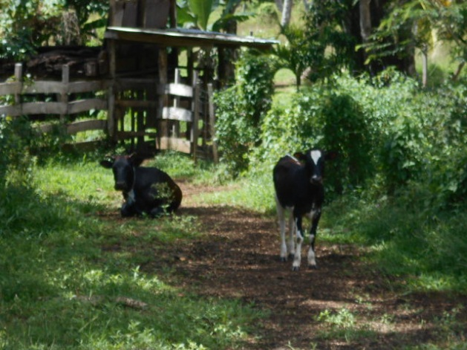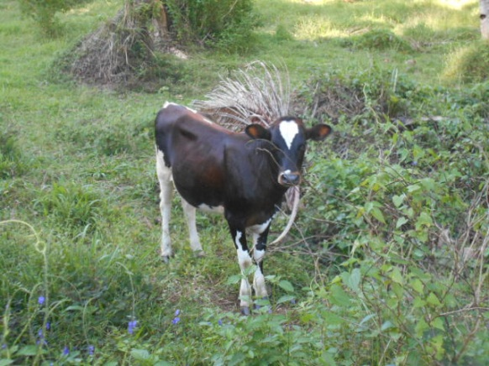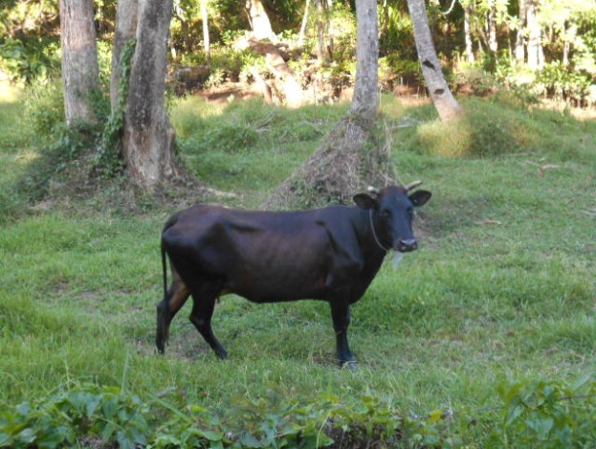

*"Therefore, for the sake of the people in general, I am requesting you to pursue this farming life with great enthusiasm. Help people to see this traditional, natural way of living. You must help them see how they can become happy, how they can go back to Godhead. So advance this project -- plain living, high thinking. This modern civilization is so nasty, a nasty civilization, artificially increasing the so-called necessities of life. Anartha -- unwanted; unbeneficial "improvements."* (quote: Srila Prabhupada)

**

**(SB 7.14.10)** Even if one is a householder rather than a brahmacārī, a sannyāsī or a vānaprastha, one should not endeavor very hard for religiosity, economic development or satisfaction of the senses. Even in householder life, one should be satisfied to maintain body and soul together with whatever is available with minimum endeavor, according to place and time, by the grace of the Lord. One should not engage oneself in ugra-karma.

**PURPORT:** *In human life there are four principles to be fulfilled—dharma, artha, kāma and mokṣa (religion, economic development, sense gratification, and liberation). First one should be religious, observing various rules and regulations, and then one must earn some money for maintenance of his family and the satisfaction of his senses. The most important ceremony for sense gratification is marriage because sexual intercourse is one of the principal necessities of the material body. Yan maithunādi-gṛhamedhi-sukhaṁ hi tuccham [SB 7.9.45]. Although sexual intercourse is not a very exalted*

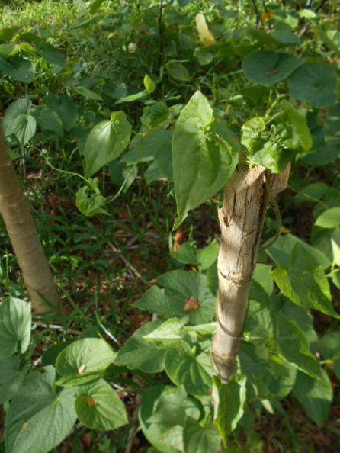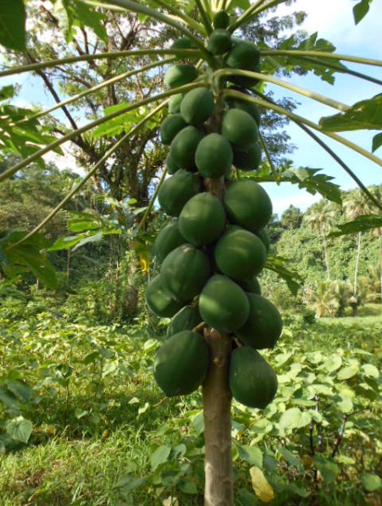

*requisite in life, both animals and men require some sense gratification because of material propensities. One should be satisfied with married life and not expend energy for extra sense gratification or sex life.*

*As for economic development, the responsibility for this should be entrusted mainly to the vaiśyas and gṛhasthas. Human society should be divided into varṇas and āśramas—brāhmaṇa, kṣatriya, vaiśya, śūdra, brahmacarya, gṛhastha, vānaprastha and sannyāsa. Economic development is necessary for gṛhasthas. Brāhmaṇa gṛhasthas should be satisfied with a life of adhyayana, adhyāpana, yajana and yājana—being learned scholars, teaching others to be scholars, learning how to worship the Supreme Personality of Godhead, Viṣṇu, and also teaching others how to worship Lord Viṣṇu, or even the demigods. A brāhmaṇa should do this without remuneration, but he is allowed to accept charity from a person whom he teaches how to be a human being. As for the kṣatriyas, they are supposed to be the kings of the land, and the land should be distributed to the vaiśyas for agricultural activities, cow protection and trade. Śūdras must work; sometimes they should engage in occupational duties as cloth manufacturers, weavers, blacksmiths, goldsmiths, brass-smiths, and so on, or else they should engage in hard labor to produce food grains.*

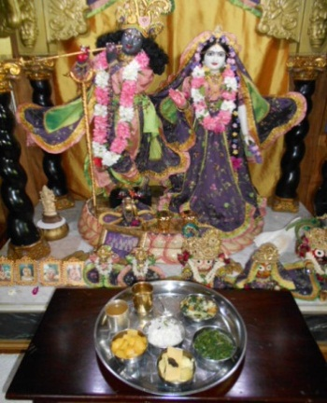

*These are the different occupational duties by which men should earn their livelihood, and in this way human society should be simple. At the present moment, however, everyone is engaged in technological advancement, which is described in Bhagavad-gītā as ugra-karma—extremely severe endeavor. This ugra-karma is the cause of agitation within the human mind. Men are engaging in many sinful activities and becoming degraded by opening slaughterhouses, breweries and cigarette factories, as well as nightclubs and other establishments for sense enjoyment. In this way they are spoiling their lives. In all of these activities, of course, householders are involved, and therefore it is advised here, with the use of the word api, that even though one is a householder, one should not engage himself in severe hardships. One’s means of livelihood should be extremely simple. As for those who are not gṛhasthas—the brahmacārīs, vānaprasthas and sannyāsīs—they don’t have to do anything but strive for advancement in spiritual life. This means that three fourths of the entire population should stop sense gratification and simply be engaged in the advancement of Kṛṣṇa consciousness. Only one fourth of the population should be gṛhastha, and that should be according to laws of restricted sense gratification. The gṛhasthas, vānaprasthas, brahmacārīs and sannyāsīs should endeavor together with their total energy to become Kṛṣṇa conscious. This type of civilization is called daiva-varṇāśrama. One of the objectives of the Kṛṣṇa consciousness movement is to establish this daiva-varṇāśrama, but not to encourage so-called varṇāśrama without scientifically organized endeavor by human society. (END)*

**SOMEONE’S PREDICTION OF THE NEAR FUTURE**

*“…living conditions continue to deteriorate rapidly, the planet gets increasingly trashed, families are being torn apart by the selfishness and narcissism produced by machine addiction and survival skills do not exist. Life-experience has been tossed over the side in favor of whatever Wikipedia or Ask Jeeves says about it. Everyone knows everything about…well…everything. People talk too much. No one listens. The information overload produces indecision, isolation, fragmentation and confusion in people. In the coming months there will be a financial collapse that will make the 1930’s look like a walk in the park. The biggest banks will fail due to the aforementioned derivatives, taking down most other smaller banks, the stock markets, commodities (including gold), housing and all else with it. Without a functioning banking system, grocery shelves could go bare, the lights may well go out, the Internet may well go down, the fake election will become irrelevant and World War III – given the current and very dicey geopolitical situation – could easily be started by an unhappy electronic accident. Preppers who have tried to buy their way to survival will perish along with the others, beside their gasless generators, rotting freeze-dried food and empty computer screens. “* (Unknown)

**TEN SAFEST COUNTRIES:** [**https://youtu.be/sVAzIFtu4d4Fiji**](https://youtu.be/sVAzIFtu4d4Fiji)

***SUMMARY***

*New Jaipur is a positive alternative to the rapidly devolving situation in the modern world. Nuclear war approaches, and humanity is due for much turmoil which can be fully alleviated by establishing Prabhupada’s varnashrama Hare Krishna farms. New Jaipur Vedic Village farm project retains Srila Prabhupada as the sole diksa guru, via ritvik representatives. We are part of Prabhupada’s transcendental mission which is situated beyond the now-corrupted original institution. Srila Prabhupada resides wherever his instructions are strictly followed. New Jaipur has 857 acres of titled, fully-paid land in a South Seas rainforest on Fiji’s second largest island. There are openings for qualified devotees based on the Village Constitution (available by email). Interested persons may inquire. The basic standards: 16 rounds daily, the four rules, community service, regular attendance to morning programs, and be a productive participant, worshipping Sri Sri Radha Govinda. Cozy cottages available. Vedic villages are the future of the world. Please consider a visit to New Jaipur, and be our guest in paradise; an invitation to like-minded Prabhupadanugas. Life here is simple but not austere. Also welcome: temporary residents who would like to further their spiritual credits by offering assistance to the Vedic village with their skills, labor, or gifts. Yours in Prabhupada’s service,*



[srigovinda@gmail.com](mailto:srigovinda@gmail.com).

Hare Krishna! All Glories to Srila Prabhupada!

NEW JAIPUR FIJI WEBSITE [www.vedicvillage.org](http://www.vedicvillage.org)